Ref. No: Date: 25/11/2023

Notice Regarding 5th Semester HONS Internal exam
It is hereby notify to all students of 5th semester HONS that an internal exam will be held on as per schedule given below at room no 205. All must come with pen, writing board and old admit card.
Paper Code | Date | Time | Day | Paper
CHEMHTDSE-2A | 15/11/2023 | 10:30 AM | Friday | Analytical
CHEMHTDSE-1B | 18/11/2023 | 10:30 AM | Monday | Industrial
CHEMHT-12 | 19/11/2023 | 10:30 AM | Tuesday | Physical
CHEMHT-11 | 20/12/2023 | 10:30 AM | Wednesday | Inorganic

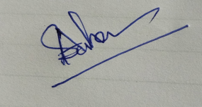
HOD
Department of Chemistry

